Topalian
JavaScript
Genetics
Navigator

by
Christopher Andrew Topalian

All Rights Reserved
Copyright 2000-2024
Dedicated
to
God the Father

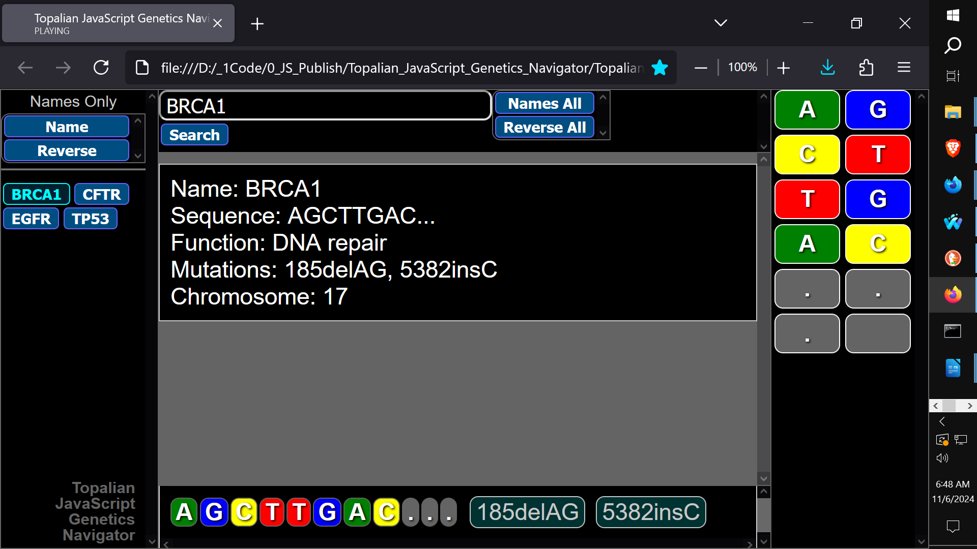
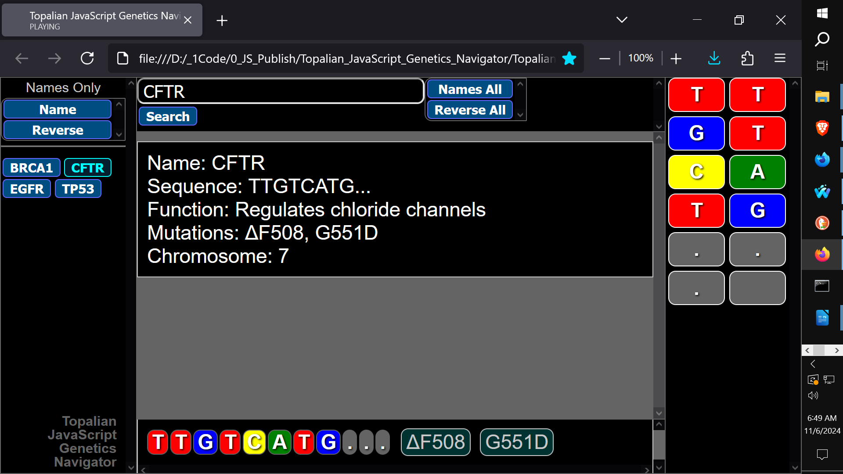
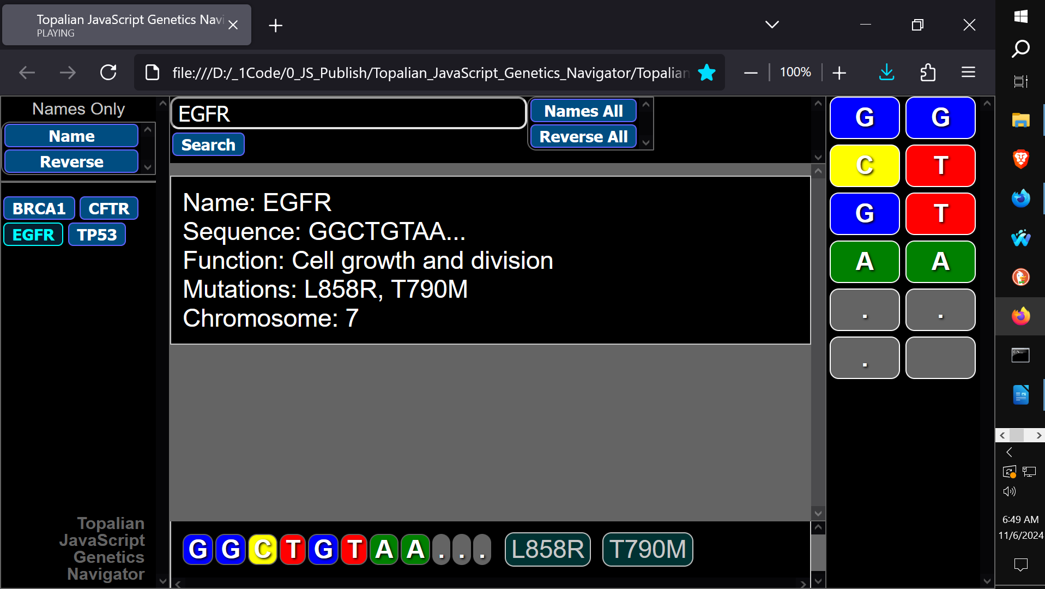
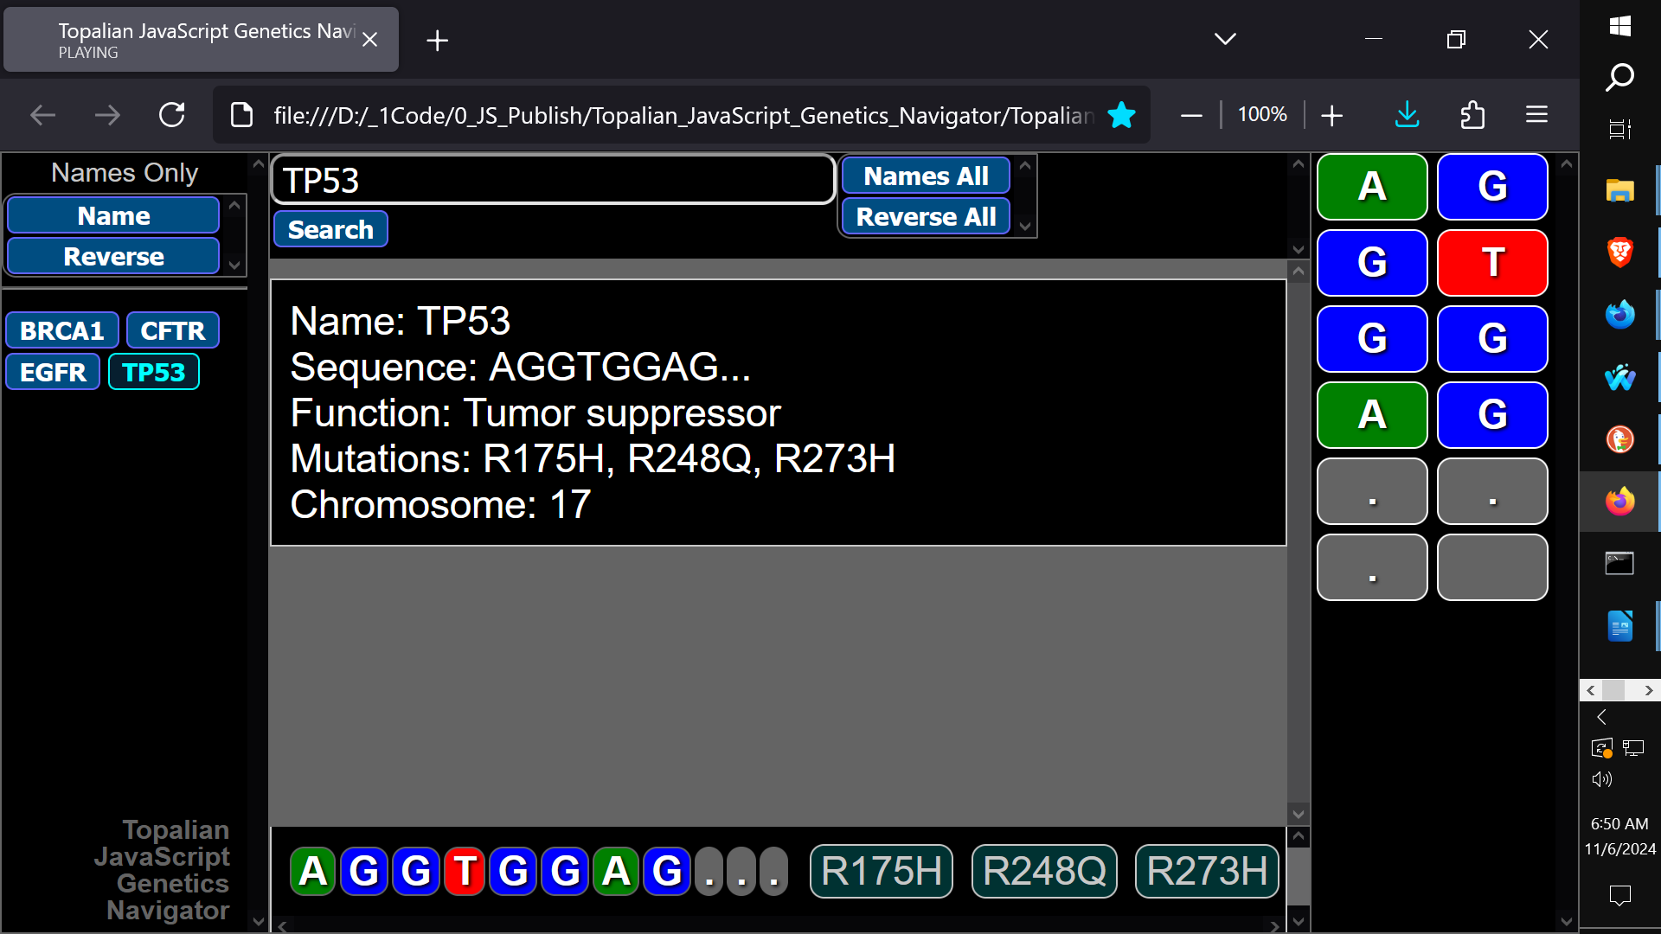

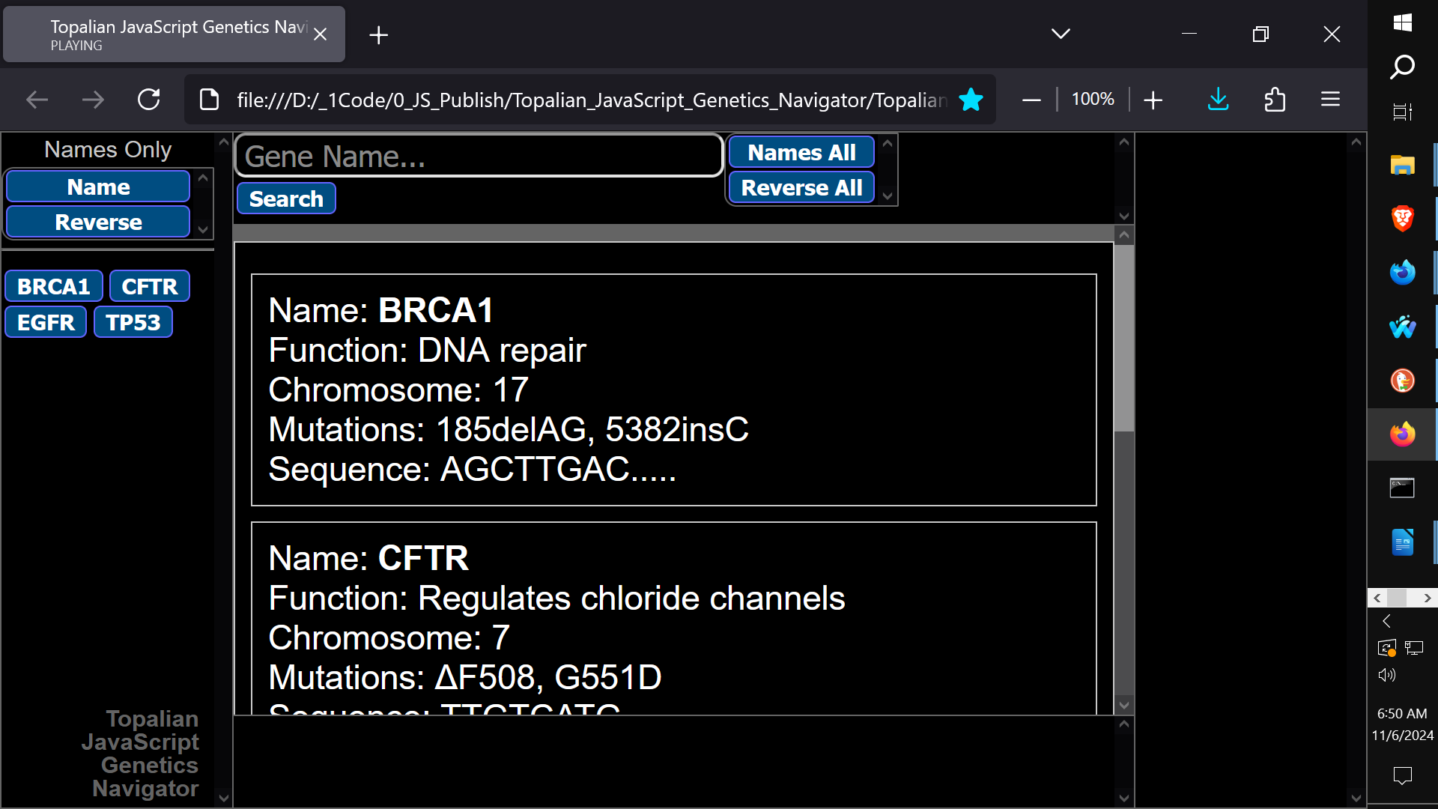
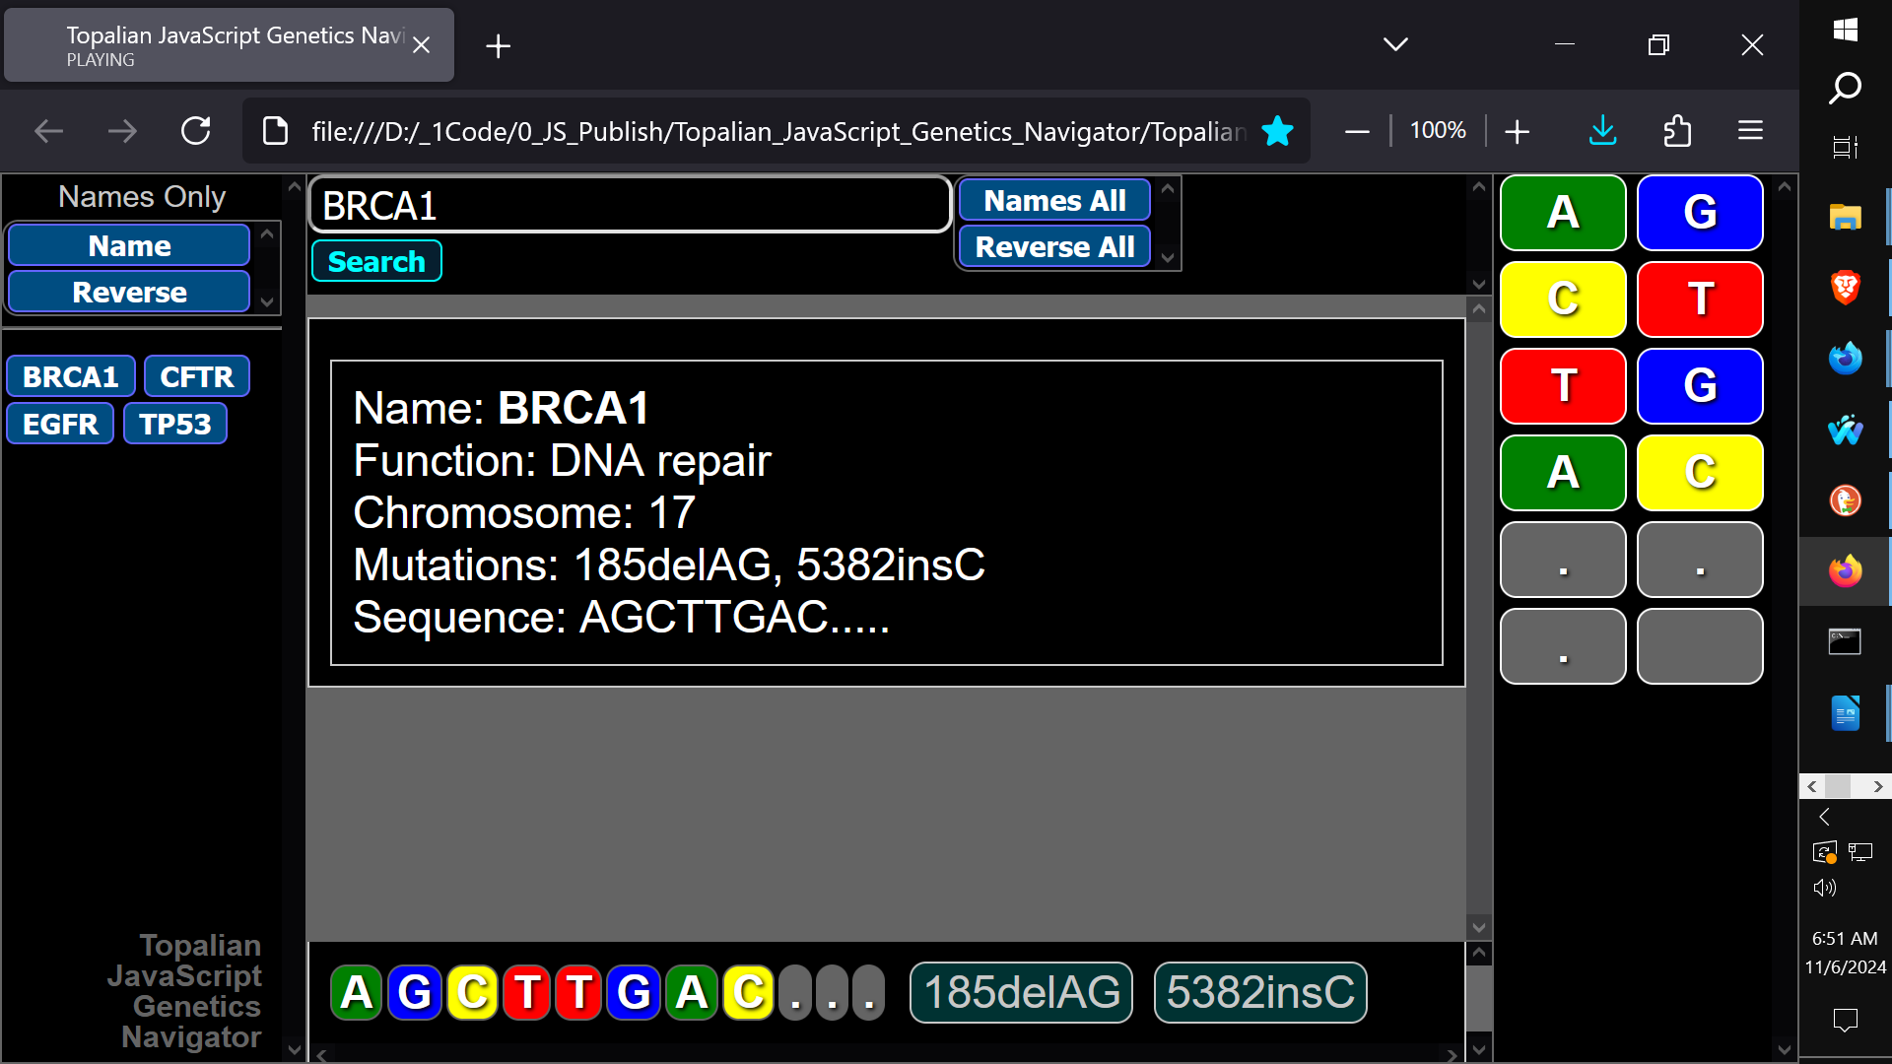
<!-- Dedicated to God the Father -->
<!-- All Rights Reserved Christopher Andrew Topalian Copyright 2000-2024 -->
<!-- https://github.com/ChristopherTopalian -->
<!-- https://github.com/ChristopherAndrewTopalian -->
<!-- Topalian_JavaScript_Genetics_Navigator_(Online_Version).html -->
<!-- Version 001 - (2024-11-06) -->

<html>
<head>
<title> Topalian JavaScript Genetics Navigator </title>

<style>

/* style001.css */

body
{
background-color: rgb(30, 30, 30);
font-family: Arial;
color: rgb(200, 200, 200);
}

a
{
color: rgb(100, 100, 100);
}

hr
{
margin-top: 5px;
}

button
{
background-color: rgb(0, 77, 129);
margin-left: 2px;
margin-right: 2px;
margin-top: 1px;
margin-bottom: 1px;
border-style: solid;
border-width: 1px;
border-color: rgb(100, 100, 255);
border-radius: 4px;
padding-left: 7px;
padding-right: 7px;
padding-top: 1px;
padding-bottom: 1px;
opacity: 1.0;
font-size: 14px;
font-weight: bold;
color: rgb(255, 255, 255);
text-align: center;
cursor: pointer;
}

button:hover
{
background-color: rgb(6, 31, 47);
border-color: rgb(0, 255, 255);
color: rgb(0, 255, 255);
}

button:active
{
color: rgb(255, 0, 255);
}

.result
{
background-color: rgb(0, 0, 0);
margin-top: 10px;
padding: 10px;
border: 1px solid rgb(200, 200, 200);
color: rgb(255, 255, 255);
}

.panel
{
background-color: rgb(0, 0, 0);
border: solid 1px rgb(100, 100, 100);
overflow-y: scroll;
}

.nucleotideSpan
{
margin-right: 2px;
border: solid 1px rgb(100, 100, 100);
border-radius: 8px;
padding-left: 4px;
padding-right: 4px;
padding-top: 0.5px;
padding-bottom: 0.5px;
font-weight: bold;
color: rgb(255, 255, 255);
text-align: center;
line-height: 30px;
text-shadow: 1px 1px 2px rgb(0, 0, 0);
cursor: pointer;
}

.nucleotideSpan:hover
{
position: relative;
top: 1px;
}

.nucleotideDiv1
{
padding: 5px;
border: 1px solid rgb(255, 255, 255);
border-radius: 8px;
font-weight: bold;
text-align: center;
text-shadow: 1px 1px 2px rgb(0, 0, 0);
cursor: pointer;
}

.nucleotideDiv1:hover
{
position: relative;
top: 1px;
}

.nucleotideDiv2
{
border: 1px solid rgb(255, 255, 255);
border-radius: 8px;
padding: 5px;
font-weight: bold;
text-align: center;
text-shadow: 1px 1px 2px rgb(0, 0, 0);
cursor: pointer;
}

.nucleotideDiv2:hover
{
position: relative;
top: 1px;
}

.mutationMarker
{
padding: 5px;
border: 1px solid rgb(100, 100, 100);
color: rgb(200, 200, 200);
text-align: center;
cursor: pointer;
}

.mutationMarker:hover
{
position: relative;
top: 1px;
}

/*----*/

/* Dedicated to God the Father */
/* All Rights Reserved Christopher Andrew Topalian Copyright 2000-2024 */
/* https://github.com/ChristopherTopalian */
/* https://github.com/ChristopherAndrewTopalian */
/* https://sites.google.com/view/CollegeOfScripting */

</style>

<script>

// shortcuts.js

function ge(whichId)
{
let result = document.getElementById(whichId);

return result;
}

function ce(whichType)
{
let result = document.createElement(whichType);

return result;
}

function ba(whichElement)
{
let result = document.body.append(whichElement);

return result;
}

function cl(whichMessage)
{
let result = console.log(whichMessage);

return result;
}

//--//

// Dedicated to God the Father
// All Rights Reserved Christopher Andrew Topalian Copyright 2000-2024
// https://github.com/ChristopherTopalian
// https://github.com/ChristopherAndrewTopalian
// https://sites.google.com/view/CollegeOfScripting

// worldVariables.js

//--//

// Dedicated to God the Father
// All Rights Reserved Christopher Andrew Topalian Copyright 2000-2024
// https://github.com/ChristopherTopalian
// https://github.com/ChristopherAndrewTopalian
// https://sites.google.com/view/CollegeOfScripting

// genesData001.js

let genes = [
{
name: `BRCA1`,
sequence: `AGCTTGAC...`,
function: `DNA repair`,
mutations: ['185delAG', '5382insC'],
chromosome: 17
},

{
name: `TP53`,
sequence: `AGGTGGAG...`,
function: `Tumor suppressor`,mutations: ['R175H', 'R248Q', 'R273H'],
chromosome: 17
},

{
name: `CFTR`,
sequence: `TTGTCATG...`,
function: `Regulates chloride channels`,
mutations: ['ΔF508', 'G551D'],
chromosome: 7
},

{
name: `EGFR`,
sequence: `GGCTGTAA...`,
function: `Cell growth and division`,
mutations: ['L858R', 'T790M'],
chromosome: 7
}
];

//--//

// Dedicated to God the Father
// All Rights Reserved Christopher Andrew Topalian Copyright 2000-2024
// https://github.com/ChristopherTopalian
// https://github.com/ChristopherAndrewTopalian
// https://sites.google.com/view/CollegeOfScripting

// makeDNAHorizontalDiagram.js

// make and display gene sequence
function makeDNAHorizontalDiagram(geneName)
{
// find gene data by name
let gene = null;

for (let i = 0; i < genes.length; i++)
{
if (genes[i].name === geneName)
{
gene = genes[i];
break;
}
}

if (!gene)
{
console.error('Gene not found!');
return;
}

// get panel element
let panelBottom = ge('panelBottom');

// clear any previous content
panelBottom.innerHTML = '';

// make a container for gene sequence
let geneContainer = ce('div');
geneContainer.style.overflowX = 'scroll';
geneContainer.style.whiteSpace = 'nowrap';
geneContainer.style.padding = '10px';
geneContainer.style.border = '1px solid rgb(204, 204, 204)';

// make nucleotide sequence display
for (let i = 0; i < gene.sequence.length; i++)
{
// current nucleotide
let nucleotide = gene.sequence[i];

// make a span for each nucleotide
let nucleotideSpan = ce('span');
nucleotideSpan.textContent = nucleotide;
nucleotideSpan.className = 'nucleotideSpan';
nucleotideSpan.style.width = '15px';
nucleotideSpan.style.height = '30px';

nucleotideSpan.onmouseover = function()
{
hoverSound2();
};

// color code nucleotides
if (nucleotide === 'A')
{
nucleotideSpan.style.backgroundColor = 'green';
}
else if (nucleotide === 'T')
{
nucleotideSpan.style.backgroundColor = 'red';
}
else if (nucleotide === 'G')
{
nucleotideSpan.style.backgroundColor = 'blue';
}
else if (nucleotide === 'C')
{
nucleotideSpan.style.backgroundColor = 'yellow';
}
else
{
nucleotideSpan.style.backgroundColor = 'rgb(100, 100, 100)';
// for unknown characters
}

geneContainer.append(nucleotideSpan);
}

//-//

// make mutation markers
for (let j = 0; j < gene.mutations.length; j++)
{
let mutationMarker = ce('span');
mutationMarker.textContent = gene.mutations[j];
mutationMarker.className = 'mutationMarker';
mutationMarker.style.backgroundColor = 'rgb(0, 50, 50)';
mutationMarker.style.padding = '2px 5px';
mutationMarker.style.marginLeft = '10px';
mutationMarker.style.border = 'solid 1px rgb(200, 200, 200)';
mutationMarker.style.borderRadius = '8px';
mutationMarker.style.cursor = 'pointer';
mutationMarker.title = 'Mutation: ' + gene.mutations[j];

mutationMarker.onmouseover = function()
{
hoverSound2();
};

geneContainer.append(mutationMarker);
}

panelBottom.append(geneContainer);
}

//--//

// Dedicated to God the Father
// All Rights Reserved Christopher Andrew Topalian Copyright 2000-2024
// https://github.com/ChristopherTopalian
// https://github.com/ChristopherAndrewTopalian
// https://sites.google.com/view/CollegeOfScripting

// makeDNAVerticalDiagram.js

function makeDNAVerticalDiagram(sequence)
{
let panelRight = ge('panelRight');
// clear previous content
panelRight.innerHTML = '';

let container = document.createElement('div');
container.style.display = 'grid';
// two equal-width columns
container.style.gridTemplateColumns = '1fr 1fr';
container.style.gridGap = '5px';
container.style.marginLeft = 4 + 'px';
container.style.marginRight = 4 + 'px';
container.style.color = 'rgb(255, 255, 255)';

panelRight.appendChild(container);

// color mapping
let nucleotideColors = {
A: { color: 'green' },
T: { color: 'red' },
C: { color: 'yellow' },
G: { color: 'blue' }
};

// loop through sequence in steps of 2
for (let i = 0; i < sequence.length; i += 2)
{
// get current pair of nucleotides
let nucleotide1 = sequence[i];

// handle odd-length sequences
let nucleotide2 = sequence[i + 1] || '';

// make and style divs for nucleotides
let nucleotideDiv1 = ce('div');
nucleotideDiv1.className = 'nucleotideDiv1';
nucleotideDiv1.style.backgroundColor = nucleotideColors[nucleotide1] ? nucleotideColors[nucleotide1].color : 'rgb(100, 100, 100)'; // set bg color
nucleotideDiv1.textContent = nucleotide1;
nucleotideDiv1.onmouseover = function()
{
hoverSound2();
};
container.append(nucleotideDiv1);

//-//

let nucleotideDiv2 = ce('div');
nucleotideDiv2.className = 'nucleotideDiv2';
nucleotideDiv2.style.backgroundColor = nucleotideColors[nucleotide2] ? nucleotideColors[nucleotide2].color : 'rgb(100, 100, 100)'; // set bg color
nucleotideDiv2.textContent = nucleotide2;
nucleotideDiv2.onmouseover = function()
{
hoverSound2();
};
container.append(nucleotideDiv2);
}
}

//--//

// Dedicated to God the Father
// All Rights Reserved Christopher Andrew Topalian Copyright 2000-2024
// https://github.com/ChristopherTopalian
// https://github.com/ChristopherAndrewTopalian
// https://sites.google.com/view/CollegeOfScripting

// makeInterface.js

function makeInterface()
{
let panelWidth = '150px';
let panelHeight = '60px';

//-//

let mainDiv = ce('div');
mainDiv.id = 'mainDiv';
ba(mainDiv);

//-//

// left panel
let panelLeft = ce('div');
panelLeft.id = 'panelLeft';
panelLeft.className = 'panel';
panelLeft.style.position = 'absolute';
panelLeft.style.left = '0px';
panelLeft.style.top = '0px';
panelLeft.style.bottom = '0px';
panelLeft.style.width = panelWidth;
mainDiv.append(panelLeft);

//-//

// right panel
let panelRight = ce('div');
panelRight.id = 'panelRight';
panelRight.className = 'panel';
panelRight.style.position = 'absolute';
panelRight.style.right = '0px';
panelRight.style.top = '0px';
panelRight.style.bottom = '0px';
panelRight.style.width = panelWidth;
mainDiv.append(panelRight);

//-//

// top panel
let panelTop = ce('div');
panelTop.id = 'panelTop';
panelTop.className = 'panel';
panelTop.style.position = 'absolute';
// starts after left panel
panelTop.style.left = panelWidth;
// ends before right panel
panelTop.style.right = panelWidth;
panelTop.style.top = '0px';
panelTop.style.height = panelHeight;
panelTop.style.display = 'flex';
panelTop.style.flexDirection = 'row';
mainDiv.append(panelTop);

//-//

// bottom panel
let panelBottom = ce('div');
panelBottom.id = 'panelBottom';
panelBottom.className = 'panel';
panelBottom.style.position = 'absolute';
// starts after left panel
panelBottom.style.left = panelWidth;
// ends before right panel
panelBottom.style.right = panelWidth;
panelBottom.style.bottom = '0px';
panelBottom.style.height = panelHeight;
mainDiv.append(panelBottom);

//-//

// center panel
let panelCenter = ce('div');
panelCenter.id = 'panelCenter';
panelCenter.className = 'panel';
panelCenter.style.position = 'absolute';
// starts after left panel
panelCenter.style.left = panelWidth;
// ends before right panel
panelCenter.style.right = panelWidth;
// starts after top panel
panelCenter.style.top = panelHeight;
// ends before bottom panel
panelCenter.style.bottom = panelHeight;
panelCenter.style.backgroundColor = 'rgb(100, 100, 100)';
mainDiv.append(panelCenter);
}

//--//

// Dedicated to God the Father
// All Rights Reserved Christopher Andrew Topalian Copyright 2000-2024
// https://github.com/ChristopherTopalian
// https://github.com/ChristopherAndrewTopalian
// https://sites.google.com/view/CollegeOfScripting

// makeLabel.js

function makeLabel(whichElement, whichText)
{
let theId = ge(whichElement);

let theLabel = ce('label');
theLabel.setAttribute('for', theId);
theLabel.textContent = whichText;
theLabel.style.fontSize = '15px';
theLabel.style.lineHeight = '14px';
theLabel.style.textAlign = 'center';
theLabel.style.display = 'block';
theLabel.style.marginTop = '4px';
theLabel.style.marginBottom = '4px';
return theLabel;
}

//--//

// Dedicated to God the Father
// All Rights Reserved Christopher Andrew Topalian Copyright 2000-2024
// https://github.com/ChristopherTopalian
// https://github.com/ChristopherAndrewTopalian
// https://sites.google.com/view/CollegeOfScripting

// makeNameButtons.js

function makeNameButtons()
{
let subDiv = ce('div');
subDiv.id = 'subDivLeft';
subDiv.title = 'subDiv';
ge('panelLeft').append(subDiv);

//-//

// label Names Only
subDiv.append(makeLabel(subDiv, 'Names Only'));

//-//

let namesContainer = ce('div');
namesContainer.id = 'namesContainer';
namesContainer.title = 'namesContainer';
namesContainer.style.overflowY = 'scroll';
namesContainer.style.border = 'solid 1px rgb(100, 100, 100)';
namesContainer.style.borderRadius = '8px';
namesContainer.style.display = 'flex';
namesContainer.style.flexDirection = 'column';
subDiv.append(namesContainer);

//-//

let nameButton = ce('button');
nameButton.id = 'nameButton';
nameButton.title = 'nameButton';
nameButton.textContent = 'Name';
nameButton.onmouseover = function()
{
hoverSound();
};
nameButton.onclick = function()
{
clickSound();

// sort by name in ascending order
genes.sort(function(a, b)
{
return a.name.localeCompare(b.name);
});

if (ge('tempDiv'))
{
ge('tempDiv').remove();
}

let tempDiv = ce('div');
tempDiv.id = 'tempDiv';
tempDiv.title = 'tempDiv';
tempDiv.style.overFlowY = 'scroll';
tempDiv.style.height = '200px';
ge('panelLeft').append(tempDiv);

//-//

for (let x = 0; x < genes.length; x++)
{
let buttonHere = ce('button');
buttonHere.textContent = genes[x].name;
buttonHere.id = genes[x].name;
buttonHere.title = genes[x].name;
buttonHere.onmouseover = function()
{
hoverSound();
};
buttonHere.onclick = function()
{
clickSound();

makeDNAHorizontalDiagram(genes[x].name);
makeDNAVerticalDiagram(genes[x].sequence);

ge('results').innerHTML =
'Name: ' + genes[x].name + '<br>' +
'Sequence: ' + genes[x].sequence + '<br>' +
'Function: ' + genes[x].function + '<br>' +
'Mutations: ' + genes[x].mutations.join(', ') + '<br>' +
'Chromosome: ' + genes[x].chromosome + '<br>';

// search box value update
ge('searchGene').value = genes[x].name;
};
tempDiv.append(buttonHere);
}
};
ge('namesContainer').append(nameButton);

//-//

let reverseButton = ce('button');
reverseButton.id = 'reverseButton';
reverseButton.title = 'reverseButton';
reverseButton.textContent = 'Reverse';
reverseButton.onmouseover = function()
{
hoverSound();
};
reverseButton.onclick = function()
{
clickSound();

genes.reverse();

if (ge('tempDiv'))
{
ge('tempDiv').remove();
}

let tempDiv = ce('div');
tempDiv.id = 'tempDiv';
tempDiv.title = 'tempDiv';
ge('panelLeft').append(tempDiv);

for(let x = 0; x < genes.length; x++)
{
let buttonHere = ce('button');
buttonHere.textContent = genes[x].name;
buttonHere.title = genes[x].name;
buttonHere.onmouseover = function()
{
hoverSound();
};
buttonHere.onclick = function()
{
clickSound();

makeDNAHorizontalDiagram(genes[x].name);

makeDNAVerticalDiagram(genes[x].sequence);

ge('results').innerHTML =
'Name: ' + genes[x].name + '<br>' +
'Sequence: ' + genes[x].sequence + '<br>' +
'Function: ' + genes[x].function + '<br>' +
'Mutations: ' + genes[x].mutations + '<br>' +
'Chromosome: ' + genes[x].chromosome + '<br>';

// search box value update
ge('searchGene').value = genes[x].name;
};
tempDiv.append(buttonHere);
}
};
ge('namesContainer').append(reverseButton);

ge('panelLeft').append(ce('hr'));
}

//--//

// Dedicated to God the Father
// All Rights Reserved Christopher Andrew Topalian Copyright 2000-2024
// https://github.com/ChristopherTopalian
// https://github.com/ChristopherAndrewTopalian
// https://sites.google.com/view/CollegeOfScripting

// makeNamesAllButtons.js

function makeNamesAllButtons()
{
let subDiv = ce('div');
ge('panelTop').append(subDiv);

//-//

let namesAllContainer = ce('div');
namesAllContainer.id = 'namesAllContainer';
namesAllContainer.style.overflowY = 'scroll';
namesAllContainer.style.border = 'solid 1px rgb(100, 100, 100)';
namesAllContainer.style.borderRadius = '8px';
namesAllContainer.style.display = 'flex';
namesAllContainer.style.flexDirection = 'column';
subDiv.append(namesAllContainer);

//-//

let nameAllButton = ce('button');
nameAllButton.id = 'nameAllButton';
nameAllButton.textContent = 'Names All';
nameAllButton.onmouseover = function()
{
hoverSound();
};
nameAllButton.onclick = function()
{
clickSound();

// sort by name in ascending order
genes.sort(function(a, b)
{
return a.name.localeCompare(b.name);
});

displayResults(genes);
};
namesAllContainer.append(nameAllButton);

//-//

let reverseAllButton = ce('button');
reverseAllButton.id = 'reverseAllButton';
reverseAllButton.textContent = 'Reverse All';
reverseAllButton.onmouseover = function()
{
hoverSound();
};
reverseAllButton.onclick = function()
{
clickSound();

genes.reverse();

displayResults(genes);
};
namesAllContainer.append(reverseAllButton);
}

//--//

// Dedicated to God the Father
// All Rights Reserved Christopher Andrew Topalian Copyright 2000-2024
// https://github.com/ChristopherTopalian
// https://github.com/ChristopherAndrewTopalian
// https://sites.google.com/view/CollegeOfScripting

// makeNamesTextbox.js

function makeNamesTextbox()
{
let theTextarea = ce('div');
theTextarea.id = 'namesTextbox';
theTextarea.style.position = 'relative';
theTextarea.style.left = cr('mainDiv').right + '500px';
theTextarea.style.top = cr('mainDiv').bottom + '1500px';
ba(theTextarea);
}

//----//

// Dedicated to God the Father
// All Rights Reserved Christopher Andrew Topalian Copyright 2000-2024
// https://github.com/ChristopherTopalian
// https://github.com/ChristopherAndrewTopalian
// https://sites.google.com/view/CollegeOfScripting

// makeResultsDiv.js

function makeResultsDiv()
{
let subDiv = ce('div');
ge('panelCenter').append(subDiv);

//-//

let resultsDiv = ce('div');
resultsDiv.id = 'results';
resultsDiv.className = 'result';
subDiv.append(resultsDiv);
}

//--//

// Dedicated to God the Father
// All Rights Reserved Christopher Andrew Topalian Copyright 2000-2024
// https://github.com/ChristopherTopalian
// https://github.com/ChristopherAndrewTopalian
// https://sites.google.com/view/CollegeOfScripting

// makeSearchBox.js

function makeSearchBox()
{
let subDiv = ce('div');
ge('panelTop').append(subDiv);

//-//

let inputField = ce('input');
inputField.type = 'text';
inputField.id = 'searchGene';
inputField.style.paddingLeft = '5px';
inputField.style.paddingRight = '5px';
inputField.style.backgroundColor = 'rgb(0, 0, 0)';
inputField.style.color = 'rgb(255, 255, 255)';
inputField.style.marginBottom = '2px';
inputField.style.borderRadius = '8px';
inputField.style.width = '100%';
inputField.placeholder = 'Gene Name...';
inputField.onmouseover = function()
{
hoverSound();
};
inputField.onclick = function()
{
clickSound();
};
subDiv.append(inputField);

//-//

subDiv.append(ce('label').textContent = ' ');

//-//

let searchButton = ce('button');
searchButton.textContent = 'Search';
searchButton.onmouseover = function()
{
hoverSound();
};
searchButton.onclick = function()
{
clickSound();

filterGenes(genes);

makeDNAHorizontalDiagram(inputField.value);

makeDNAVerticalDiagram(genes[findIndexByName(genes, inputField.value)].sequence);
};
subDiv.append(searchButton);
}

//--//

// Dedicated to God the Father
// All Rights Reserved Christopher Andrew Topalian Copyright 2000-2024
// https://github.com/ChristopherTopalian
// https://github.com/ChristopherAndrewTopalian
// https://sites.google.com/view/CollegeOfScripting

// makeTitleOfApp.js

function makeTitleOfApp()
{
let theTitle = ce('a');
theTitle.id = 'theTitle';
theTitle.href = 'https://github.com/ChristopherTopalian';
theTitle.target = '_blank';
theTitle.textContent = 'Topalian JavaScript Genetics Navigator';
theTitle.style.position = 'absolute';
theTitle.style.right = 0 + 'px';
theTitle.style.bottom = -5 + 'px';
theTitle.style.margin = 10 + 'px';
theTitle.style.fontSize = '15px';
theTitle.style.fontWeight = 'bold';
theTitle.style.textAlign = 'right';
theTitle.style.lineHeight = 15 + 'px';
theTitle.style.textDecoration = 'none';
panelLeft.append(theTitle);
}

//--//

// Dedicated to God the Father
// All Rights Reserved Christopher Andrew Topalian Copyright 2000-2024
// https://github.com/ChristopherTopalian
// https://github.com/ChristopherAndrewTopalian
// https://sites.google.com/view/CollegeOfScripting

// filterGenes.js

function filterGenes(whichArray)
{
let searchValue = ge('searchGene').value.toLowerCase();

let filteredGenes = [];

for (let i = 0; i < whichArray.length; i++)
{
if (whichArray[i].name.toLowerCase().includes(searchValue))
{
filteredGenes.push(whichArray[i]);
}
}

displayResults(filteredGenes);
}

//--//

// Dedicated to God the Father
// All Rights Reserved Christopher Andrew Topalian Copyright 2000-2024
// https://github.com/ChristopherTopalian
// https://github.com/ChristopherAndrewTopalian
// https://sites.google.com/view/CollegeOfScripting

// findIndexByName.js

function findIndexByName(whichArray, whichName)
{
let index = whichArray.findIndex(function(a)
{
return a.name === whichName
});

return index;
}

//--//

// Dedicated to God the Father
// All Rights Reserved Christopher Andrew Topalian Copyright 2000-2024
// https://github.com/ChristopherTopalian
// https://github.com/ChristopherAndrewTopalian
// https://sites.google.com/view/CollegeOfScripting

// displayResults.js

function displayResults(filteredGenes)
{
let resultsDiv = ge('results');

resultsDiv.innerHTML = '';

if (filteredGenes.length === 0)
{
resultsDiv.innerHTML = 'No results found.';
return;
}

for (let i = 0; i < filteredGenes.length; i++)
{
let geneDiv = ce('div');
geneDiv.className = 'result';
resultsDiv.append(geneDiv);

//-//

let geneNameDiv = ce('div');
geneNameDiv.innerHTML = 'Name: ' + '<b>' + filteredGenes[i].name + '</b>';
geneDiv.append(geneNameDiv);

//-//

let geneFunctionDiv = ce('div');
geneFunctionDiv.textContent = 'Function: ' + filteredGenes[i].function;
geneDiv.append(geneFunctionDiv);

//-//

let geneChromosomeDiv = ce('div');
geneChromosomeDiv.textContent = 'Chromosome: ' + filteredGenes[i].chromosome;
geneDiv.append(geneChromosomeDiv);

//-//

let geneMutationsDiv = ce('div');
geneMutationsDiv.textContent = 'Mutations: ' + filteredGenes[i].mutations.join(', ');
geneDiv.append(geneMutationsDiv);

//-//

let geneSequenceDiv = ce('div');
geneSequenceDiv.textContent = 'Sequence: ' + filteredGenes[i].sequence.substring(0, 10) + '...';
geneDiv.append(geneSequenceDiv);
}
}

//--//

// Dedicated to God the Father
// All Rights Reserved Christopher Andrew Topalian Copyright 2000-2024
// https://github.com/ChristopherTopalian
// https://github.com/ChristopherAndrewTopalian
// https://sites.google.com/view/CollegeOfScripting

// sound.js

let audioCtx = new (window.AudioContext || window.webkitAudioContext)();

function playTone(frequency, duration, waveType, volume, detune, attackTime, releaseTime, panValue)
{
let oscillator = audioCtx.createOscillator();
// 'sine', 'square', 'sawtooth', 'triangle'
oscillator.type = waveType;
oscillator.frequency.setValueAtTime(frequency, audioCtx.currentTime);
oscillator.detune.setValueAtTime(detune, audioCtx.currentTime);

let gainNode = audioCtx.createGain();
let pannerNode = audioCtx.createStereoPanner();

oscillator.connect(gainNode);
gainNode.connect(pannerNode);
pannerNode.connect(audioCtx.destination);

gainNode.gain.setValueAtTime(0, audioCtx.currentTime);

// attack
gainNode.gain.linearRampToValueAtTime(volume, audioCtx.currentTime + attackTime);
gainNode.gain.linearRampToValueAtTime(0,

// release
audioCtx.currentTime + duration / 1000 - releaseTime);

pannerNode.pan.setValueAtTime(panValue, audioCtx.currentTime);

oscillator.start();
oscillator.stop(audioCtx.currentTime + duration / 1000);
}

function hoverSound()
{
playTone(
300, // frequency
500, // duration
'sine', // waveType
0.1, // volume
50, // detune
0.2, // attackTime
0.2, // releaseTime
-0.5 // panValue -0.5 is left
);
}

function hoverSound2()
{
playTone(
300, // frequency
300, // duration
'triangle', // waveType
0.08, // volume
-200, // detune
0.1, // attackTime
0.1, // releaseTime
0.0 // panValue -0.5 is left
);
}

function clickSound()
{
playTone(
400, // frequency
500, // duration
'sine', // waveType
0.1, // volume
50, // detune
0.2, // attackTime
0.2, // releaseTime
-0.5 // panValue -0.5 is left
);
}

//--//

// Dedicated to God the Father
// All Rights Reserved Christopher Andrew Topalian Copyright 2000-2024
// https://github.com/ChristopherTopalian
// https://github.com/ChristopherAndrewTopalian
// https://sites.google.com/view/CollegeOfScripting

// whenLoaded.js

function whenLoaded()
{
makeInterface();

makeSearchBox();

makeNameButtons();

makeNamesAllButtons();

makeResultsDiv();

makeTitleOfApp();
}

//--//

// Dedicated to God the Father
// All Rights Reserved Christopher Andrew Topalian Copyright 2000-2024
// https://github.com/ChristopherTopalian
// https://github.com/ChristopherAndrewTopalian
// https://sites.google.com/view/CollegeOfScripting

</script>

</head>

<body onload = "whenLoaded();">

</body>

</html>

True Artificial Intelligence System
Tautology
1111
Contra-
-diction
0000
XOR
0110
XNOR
1001
AND
0001
NAND
1110
OR
0111
NOR
1000
MI
1101
MNI
0010
LP
0011
LC
1100
RP
0101
RC
1010
CI
1011
CNI
0100
16-Gon
For More Tutorials:

GitHub.com/ChristopherTopalian
GitHub.com/ChristopherAndrewTopalian
Sites.google.com/view/CollegeOfScripting
CollegeOfScripting.weebly.com
CollegeOfScripting.wordpress.com
Youtube.com/ScriptingCollege
Twitter.com/CollegeOfScript
Rumble.com/user/CollegeOfScripting

Dedicated to God the Father

This book is created by the
College of Scripting Music & Science.
Always remember, that each time you write a script with a pencil and paper, it becomes imprinted so deeply in memory that the material and methods are learned extremely well.

When you Type the scripts, the same is true. The more you type and write out the scripts by keyboard or pencil and paper, the more you will learn programming!

Write and Type every example that you find.
Keep all of your scripts organized.
Every script that you create increases your programming abilities.
SEEING CODE, is one thing,
but WRITING CODE is another.
Write it, Type it, Speak it, See it, Dream it.

CollegeOfScripting.weebly.com

